# Problem Statement

**1.1 Write a Python Program (with class concepts) to find the area of the triangle using the below formula.**

**Area = (s*(s-a)*(s-b)*(s-c)) ** 0.5**

**Function to take the length of the sides of triangle from user should be defined in the parent class and function to calculate the area should be defined in subclass.**

**Solution:**

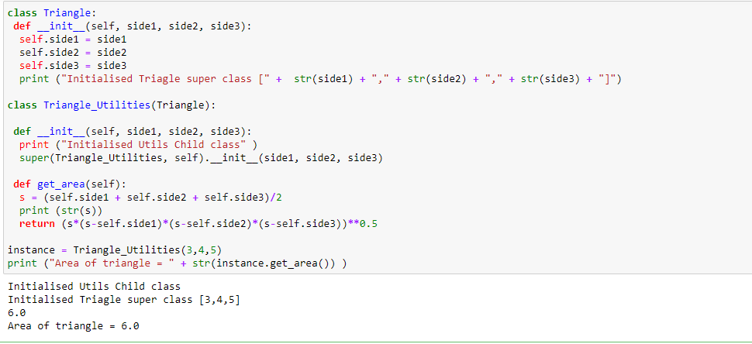

**1.2 Write a function filter_long_words () that takes a list of words and an integer n and returns the list of words that are longer than n.**

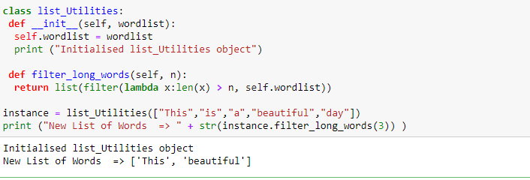

**2.1 Write a Python program using function concept that maps list of words into a list of integers representing the lengths of the corresponding words.**

**Hint: If a list [ab, cde, erty] is passed on to the python function output should come as [2,3,4]**

**Here 2, 3 and 4 are the lengths of the words in the list.**

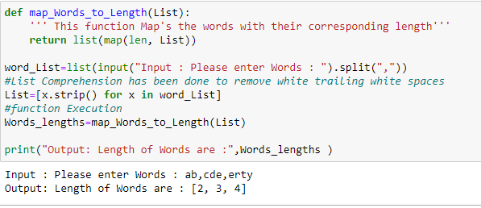

**2.2 Write a Python function which takes a character (i.e. a string of length 1) and returns True if it is a vowel, False otherwise.**

